Contents

**Abstract** 1

**Chapter 1 – Introduction** 2

**1.1 Background** 2

**1.2 Aim** 4

**1.3 Objectives** 5

**Chapter 2 - Research Design** 6

**2.1 Research Problem** 6

**2.2 Research Questions** 8

**2.3 Research Design Components** 9

**2.4 Study Design and Justification** 9

**Chapter 3 - Literature Study** 10

**3.1 Personalized Nutrition** 10

**3.2 Machine Learning in Health Applications** 11

**3.3 User-Centric Design in Health Applications** 11

**3.4 Evaluation of Health Applications** 12

**3.5 Ethical and Regulatory Considerations** 13

**Chapter 4 - Methodology** 15

**4.1 Data Collection** 15

**4.2 Data Analysis for Dataset** 17

**Chapter 5 – Discussion** 27

**5.1 User Registration and Login** 27

**5.2 Form Data Collection** 29

**5.3 Database Interaction** 30

**5.4 Food Suggestion Algorithm** 31

**5.5 Dynamic Rendering** 31

**Chapter 6 - Recommendations & Conclusion** 32

**6.1 Recommendations** 32

**6.2 Conclusion** 34

# **Abstract**

The purpose of this review is to determine how well a meal recommendation application works to encourage better eating practices and enhance general health outcomes. The study assesses how well the application meets users' needs and encourages the adoption of healthy eating habits by concentrating on user involvement, contentment, and adherence to suggested dietary modifications. By means of an extensive examination of user metrics, satisfaction surveys, and dietary adherence, the assessment offers valuable insights into the effectiveness of the application in fostering well-being and proposes potential areas for future development. Nutrigenomics and nutrigenomics, which study the relationships between nutrients and genes, are the foundation of personalized nutrition. Studies have demonstrated that genetic differences can have a major impact on an individual's food metabolism and response to dietary treatments, indicating that tailored dietary advice may be more successful than standard approaches. Genetic polymorphisms, for instance, can impact glucose tolerance and lipid metabolism, which can have an impact on dietary requirements and health consequences (Holzapfel et al., 2021; Zeisel, 2020).In order to provide personalized dietary recommendations, machine learning (ML) algorithms analyse complicated health data, which is a critical component of this personalized strategy. Algorithms that can anticipate how a person will react to a certain nutrient or diet are those that use clustering and classification to divide people into groups with comparable dietary needs. By continuously learning from user comments and health outcomes, reinforcement learning can further optimize dietary regimens (Ngiam & Khor, 2019; Nurmi & Lohan, 2021). Research by Chiu et al. (2021) demonstrates the application of ML in health data analysis, illustrating its potential to enhance dietary recommendations through personalized insights.

# **Chapter 1 – Introduction**

## **1.1 Background**

In recent years, the field of personalized diet and health management has gained significant momentum. This trend is driven by the increasing recognition of the benefits of tailored dietary recommendations in managing weight and improving overall health. Nutrigenomics research, which explores the relationship between an individual's genetic makeup and their response to nutrients, has been pivotal in this development. Studies by (Holzapfel et al. 2021, Aruoma et al. (2019), and (Drabsch & Holzapfel 2019) highlight the potential advantages of customized dietary plans based on genetic insights. This personalized approach to nutrition has been further underscored by advancements in precision nutrition, emphasizing the importance of understanding metabolic variations and individual responses to dietary interventions (Zeisel, 2020). The potential for effective health management has been enhanced by the creation of healthcare applications that offer personalized recommendations and insights, made possible by the integration of big data and machine learning algorithms (Ngiam & Khor, 2019; Nurmi & Lohan, 2021; Tohka & Van Gils, 2021). A change from the conventional one-size-fits-all dietary recommendations to more individualized strategies is represented by personalized nutrition. This change is based on the realization that a person's dietary requirements and responses are greatly influenced by hereditary, environmental, and lifestyle factors. In this individualized approach, nutrigenomics plays a critical role by examining the ways in which genes interact with dietary components and impact health outcomes.

Genetic variants can impact an individual's ability to metabolize particular nutrients, which can impact that person's likelihood of acquiring certain health conditions (Holzapfel et al., 2021; Aruoma et al., 2019). For example, certain individuals may be more prone to diseases like obesity or diabetes due to genetic variations that alter how they metabolize fats or sugars. Personalized nutrition can assist in creating nutritional interventions that are more successful for individual needs by recognizing these genetic variations. A subcategory of personalized nutrition called precision nutrition looks more closely at individual differences in metabolism. It acknowledges that due to differences in their individual metabolic profiles, people react differently to the same nutrients. Zeisel (2020) emphasizes how important it is to comprehend these metabolic variations in order to create dietary recommendations that are more successful. In order to determine a person's metabolic status, metabolic profiling analyzes indicators such as blood glucose levels, lipid profiles, and other metabolites. Customized food suggestions that maximize metabolic health can be made using this information. For instance, a diet rich in fiber and healthy fats and lower in carbohydrates may be beneficial for someone who has a propensity for elevated blood sugar levels. These customized programs can aid in preventing chronic illnesses, controlling weight more effectively, and enhancing general health.

Nutrition and tailored health have undergone a revolution thanks to big data and machine intelligence. Enormous volumes of data from metabolic profiling, genetic testing, and lifestyle monitoring can be subjected to advanced algorithms for pattern recognition and customized recommendation generation. (Ngiam & Khor 2019), (Nurmi & Lohan 2021), and (Tohka & Van Gils 2021) talk about how these technologies have made it possible to create healthcare apps that offer individualized, real-time nutritional and health recommendations. Personalized nutrition programs can be generated by machine learning algorithms that examine data from multiple sources, such as genetic information, food habits, physical activity, and health outcomes. As additional data regarding a person's reactions to various dietary interventions is incorporated, these algorithms can learn from the data and gradually improve their suggestions. Numerous healthcare applications that provide individualized dietary plans and health management services have been made possible by the combination of big data and machine learning. These apps can monitor a person's food consumption, level of physical activity, and other health indicators, and they can provide customized suggestions based on that person's individual data. An app might, for example, use genetic data to recommend particular dietary adjustments that can help control blood sugar or cut cholesterol. Additionally, it may detect how closely the user is following these suggestions and offer encouragement and feedback to help them stay on course. These apps are quite good at assisting people in making educated decisions regarding their nutrition and overall health because they are real-time.

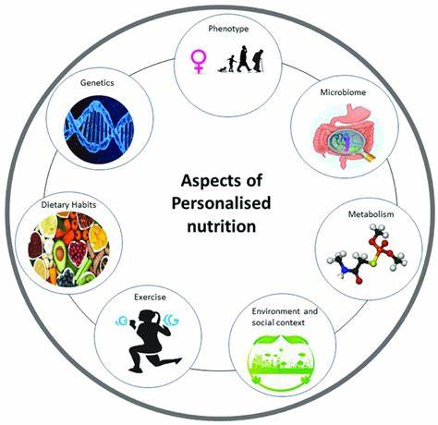

Personalized nutrition utilizes insights from nutrigenomics, precision nutrition, and advanced data analytics to tailor dietary recommendations to individual needs. This image illustrates the concept of personalized nutrition by depicting a plate filled with diverse foods, reflecting the customization of dietary advice based on factors such as genetic variations, metabolic health, and lifestyle preferences. Surrounding the plate are icons representing key elements of personalized nutrition, including genetics, data analytics, and personalized health care. These icons symbolize the integration of nutrigenomics research, big data analytics, and machine learning algorithms in the development of personalized dietary plans. By leveraging these technologies and insights, personalized nutrition aims to optimize health outcomes, improve adherence to dietary interventions, and reduce the risk of diet-related diseases.

## **1.2 Aim**

This project aims to develop and evaluate a food recommendation application that uses personalized dietary guidance to encourage better eating habits and enhance general health outcomes. The program's goal is to provide personalized meal recommendations based on each user's individual requirements and preferences by utilizing cutting-edge machine learning algorithms and user-centric design techniques. To provide individualized nutrition recommendations, the program will combine data from multiple sources, such as genetic information, dietary practices, health indicators, and lifestyle factors. The software will improve its recommendations through ongoing learning and modification to better suit users' changing preferences and health objectives.

The ultimate objective is to enable customers to make knowledgeable food decisions and sustainable lifestyle adjustments that promote their long-term wellbeing. The app aims to improve user engagement and commitment to good eating habits by offering useful insights and easy-to-use meal planning tools. By showcasing the effectiveness of tailored nutrition interventions, this research aims to advance both individual health outcomes and more general public health goals. Ultimately, the goal of this project is to empower users to take control of their health through personalized nutrition. By providing scientifically-backed, individualized meal plans and fostering a deeper understanding of healthy eating practices, the application aims to support users in achieving their long-term wellbeing and enhancing their quality of life.

## **1.3 Objectives**

The principal aim of this project is to create an all-inclusive food recommendation system that utilizes individualised dietary advice to promote better eating practises and enhance general health outcomes. Several precise, measurable, attainable, relevant, and time-bound (SMART) sub-objectives can be decomposed from this main goal: The first objective is to develop a robust food suggestion application that integrates personalized dietary recommendations based on individual health profiles and preferences. Data Collection and Integration gathering extensive information from consumers about their eating patterns, lifestyle choices, genetics, and health measurements (such blood sugar, cholesterol, and BMI). making certain that this data is freely accessible for analysis and is preserved securely Algorithm Development using cutting edge machine learning algorithms to analyse the information gathered and provide customized meal recommendations. These algorithms could use reinforcement learning to continuously optimize diet recommendations based on user feedback and clustering to identify user subgroups with comparable dietary demands. **User Interface Design:** Designing an intuitive, user-friendly interface that allows users to input their data, receive meal suggestions, and provide feedback on the recommendations. The design should prioritize ease of use and engagement to ensure high user retention and satisfaction. **Implementation of Machine Learning Algorithms**

The secondary aim is to leverage machine learning capabilities to scrutinize user information and produce customized meal recommendations that conform to suggested nutritional protocols. Algorithm Education using large datasets, machine learning models are trained to find trends and connections between user attributes and the best dietary decisions. High accuracy and dependability of the recommendations produced should be guaranteed by this training procedure (Chiu et al., 2021). Customization and Flexibility: ensuring that the algorithms can provide dynamic and ever-evolving dietary recommendations in response to feedback from specific users and shifting health metrics over time. In order to continuously enhance and modify the recommendations, this involves implementing user feedback loops **Validation and Testing:** Conducting rigorous testing and validation of the algorithms to ensure their effectiveness and reliability. This includes cross-validation with existing dietary guidelines and user studies to assess the accuracy and user satisfaction of the meal suggestions

Evaluation of Application Effectiveness the application's ability to encourage better eating practices, increase user satisfaction and engagement, and make it easier for users to follow dietary recommendations is the third goal to be assessed. Metrics for User Engagement measuring engagement levels by keeping an eye on data including the quantity of active users, app usage frequency, and user retention rates, high engagement is a crucial sign of an application's usability and usefulness to users. Metrics for health outcomes evaluating changes in blood glucose, cholesterol, weight, BMI, and other health indicators to determine how the dietary suggestions have affected the users' health. These measurements offer concrete proof of the app's success in encouraging a healthy diet. **User Satisfaction and Feedback** gathering qualitative feedback from users through surveys and interviews to understand their experiences and identify areas for improvement. User satisfaction is critical for the long-term success and sustainability of the application. **Identifying Strengths and Areas for Improvement**Using user feedback and performance indicators, the fourth goal is to pinpoint the application's functional and design strengths and areas for improvement.

Usability Testing Performing usability tests to find any functional or design flaws that detract from the user experience. For the application to be improved iteratively, this feedback is crucial. Performance Analysis Examining how well machine learning algorithms work in practical contexts to find any anomalies or potential improvement areas. The algorithms are continuously monitored and improved upon to guarantee their continued efficacy and accuracy. **Ethical and Regulatory Compliance e**nsuring the application complies with ethical standards and regulatory requirements related to data privacy, informed consent, and algorithmic transparency. Addressing these considerations is vital for maintaining user trust and the ethical use of data.

# **Chapter 2 - Research Design**

## **2.1 Research Problem**

The increasing occurrence of diet-related health problems, such diabetes, obesity, and heart disease, highlights the necessity of efficient dietary strategies. Many people have inferior health outcomes as a result of traditional dietary standards' frequent failure to take individual variances in genetic makeup, metabolic profiles, and personal preferences into consideration. By creating a meal suggestion application that offers individualized dietary suggestions to encourage better eating practices and enhance general health outcomes, our research seeks to solve this issue. The majority of dietary recommendations are broad and do not take into account individual differences. Genetic variations can have a major impact on nutrition metabolism and health outcomes, as evidenced by nutrigenomics and nutrigenomics research (Aruoma et al., 2019). For instance, variations in genes involved in lipid metabolism can influence how different individuals respond to dietary fats, affecting their risk of developing cardiovascular diseases (Drabsch & Holzapfel, 2019). By not accounting for these individual differences, generalized dietary guidelines may not be effective for everyone.

It can be difficult for people to stick to healthy eating habits over time, even when they are given nutritional recommendations. Dietary decisions are heavily influenced by a number of factors, including convenience, cultural preferences, and way of life. According to (Holzapfel et al. 2021), a customized strategy that takes these variables into account may improve dietary guideline adherence. Creating a system that can dynamically adjust to shifting user preferences and health conditions is the difficult part. The intricacy required to offer genuinely customized recommendations is sometimes absent from dietary solutions and programs now in use. Many provide nutritional recommendations based on user-reported data, which is sometimes erroneous and lacking. Additionally, these tools frequently fail to engage users in a meaningful way, resulting in low adherence and engagement rates (Ngiam & Khor, 2019). Dietary recommendation systems are still in the early phases of integrating cutting-edge technologies like machine learning and data analytics. It is quite difficult to create algorithms that can reliably evaluate and comprehend complicated health data in order to offer individualized recommendations. Furthermore, considering the sensitive nature of health information, protecting user data privacy and security is essential (Kasula, 2021).

This study's main goal is to create and assess a food recommendation application that uses individualized dietary advice to encourage better eating practices and enhance general health outcomes. Through the use of user-centric design approaches and machine learning techniques, the program seeks to provide customized meal suggestions that cater to each user's unique needs and tastes. Improving public health outcomes requires addressing the research challenge. Individualized dietary advice can result in greater adherence to a healthy diet, a lower chance of developing chronic illnesses, and an all-around increase in wellbeing. Furthermore, more individualized healthcare solutions that address a wider range of health conditions than only nutrition may be made possible by the advancement of advanced dietary tools (Zahid & Sharma, 2023). In order to ensure that the meal recommendation application satisfies user demands and produces the intended health outcomes, the research objectives are essential for directing the development and evaluation process. The research aims to achieve the following outcomes.

Create a Food Suggestion App with Personalized Dietary Advice Integrated The main goal is to develop an application that provides tailored eating recommendations according to each user's tastes and health profile. In order to customize meal recommendations that satisfy users' individual needs, this entails combining data from multiple sources, including genetic information, health condition, and dietary preferences (Aruoma et al., 2019). The software should be easy to use, entertaining, and able to make dynamic recommendations based on the preferences and changing health situations of its users. Apply Algorithms for Machine Learning to Examine User Data. The gathered data will be analyzed by machine learning algorithms to produce individualized nutritional recommendations. The dietary recommendations are informed by patterns and correlations found in the complex health data processed by these algorithms. Techniques such as supervised learning for prediction and clustering for user segmentation will be utilized to ensure the recommendations are accurate and relevant (Ngiam & Khor, 2019; Chiu et al., 2021). The impact of the application on encouraging better eating practices, raising user satisfaction and engagement levels, and making it easier for users to follow dietary guidelines will all be thoroughly examined. Health metrics tracking, user interviews, surveys, and other quantitative and qualitative methodologies will all be used in this. The purpose of the study is to ascertain whether the application helps users make better food decisions and achieve improved health outcomes (Holzapfel et al., 2021).

Utilizing User Input to Determine Strengths and Opportunities for Development In order to determine the application's design and functionality's strong points and potential areas for development, user feedback is crucial. In order to understand user experiences and preferences, this goal entails gathering feedback through focus groups, interviews, and usability testing. Insights gained from this feedback will inform iterative improvements to the application, ensuring it meets user needs and expectations (Koumpouros, 2022). Ensuring the ethical and secure processing of user information is a vital objective, especially considering the sensitive nature of health data. In addition to implementing strong security measures to safeguard user privacy, the application must abide with data protection laws like GDPR and HIPAA. To establish and preserve trust, users' informed consent shall be sought, and transparency regarding data usage will be upheld (Kasula, 2021). Sustainability and long-term involvement are crucial to the application's success. This goal is to develop elements like interactive interfaces, real-time feedback, and individualized user experiences that promote continued use. Strategies to maintain user motivation and adherence to dietary recommendations will be explored to ensure sustained benefits over time (Abd-Alrazaq et al., 2020). Data integration from wearable devices will be investigated to improve the accuracy and customisation of food advice. Incorporating real-time health measurements from wearable devices, such as sleep patterns and physical activity levels, with food recommendations can offer a more comprehensive approach to health management (Nurmi & Lohan, 2021).

## **2.2 Research Questions**

* How can a food recommendation app be created to offer customized dietary advice depending on each user's tastes and health profile?
* Based on user data analysis, which machine learning algorithms produce the most individualized dietary recommendations?
* How do users' eating habits, engagement, satisfaction, and health outcomes change as a result of the meal suggestion application?
* Based on user feedback, what are the application's functional and design strengths and areas for improvement?
* What steps must be taken to adhere to data protection laws, and how can the application guarantee the safe and moral processing of user data?
* What attributes and tactics can be used to encourage sustained user participation and adherence to individualized dietary advice?
* How can the accuracy and customisation of nutritional advice be improved by integrating data from wearable devices?

## **2.3 Research Design Components**

A number of crucial components that support the creation and assessment of the meal recommendation application are included in the research design. To train machine learning algorithms, assess the efficacy of the program, and pinpoint areas for improvement, data on user health profiles, food preferences, usage patterns, and feedback must be gathered. Focus groups, questionnaires, interviews, and measuring health measurements are some of the data collection techniques. Choosing the right algorithms, training them on gathered data, and testing their efficacy are all necessary steps in developing machine learning algorithms that analyze user data and produce customized nutritional recommendations. To guarantee precise and pertinent recommendations, methods including reinforcement learning, clustering, and supervised learning will be used. Requirement analysis, design, development, and testing are some of the phases involved in creating and executing the meal recommendation application. We'll apply user-centric design concepts to produce an engaging and user-friendly interface that caters to their wants and preferences.

Determining the application's efficacy necessitates analysing how it affects the adoption of dietary guidelines, encourages users to eat more healthfully, and increases user satisfaction. Usability testing, user interviews, surveys, and health metrics tracking are examples of evaluation techniques. It is critical to guarantee the security and moral management of user data. To preserve trust and openness, steps including getting informed consent, safeguarding user privacy, and adhering to data protection laws will be put in place. The application's longevity depends on the features and approaches that are created to encourage long-term user involvement and adherence to individualized nutrition recommendations. To promote ongoing use, interactive interfaces, real-time feedback, and customized user experiences will be investigated. Investigating how to improve the accuracy and personalization of nutritional advice by incorporating data from wearable devices into the application. To provide a more all-encompassing approach to health management, real-time health metrics from wearable devices—such as physical activity levels and sleep patterns will be included.

## **2.4 Study Design and Justification**

A mixed-methods strategy is used in the research design to combine quantitative and qualitative techniques in order to provide a thorough understanding of the creation, application, and assessment of the meal suggestion application. Numerical data that may be statistically analysed is provided via quantitative techniques including machine learning algorithms, health metrics tracking, and surveys. These techniques are useful for evaluating how well the application encourages better eating practices, raises user satisfaction and engagement, and makes following dietary guidelines easier. Quantitative data offers important insights into the efficacy of the application by enabling objective assessment and comparison of results. These techniques provide detailed insights into the experiences, opinions, and preferences of users. Examples of qualitative techniques include focus groups, interviews, and user feedback analysis. These techniques are crucial for comprehending the subtleties of how users engage with the program, spotting its advantages and disadvantages, and investigating the motivations behind users' activities. In addition to complementing quantitative findings, qualitative data offers rich context and a more comprehensive knowledge of the study issues.

The research design takes advantage of the advantages of both quantitative and qualitative methodologies by integrating them, providing a more thorough and nuanced knowledge of the creation, application, and assessment of the meal suggestion application. Triangulation of data, validation of results, and investigation of intricate correlations between variables are all made possible by this mixed-methods approach. Furthermore, it strengthens the validity, generalizability, and credibility of the study findings, allowing for stronger recommendations and conclusions.

# **Chapter 3 - Literature Study**

The way we think about nutrition and health could be completely changed by combining cutting-edge technology like machine intelligence with individualized dietary recommendations. Personalized nutrition aims to enhance health outcomes and encourage long-lasting good eating habits by customizing dietary recommendations to individual features such genetics, microbiome, lifestyle, and health status. This review of the literature explores the scientific underpinnings, approaches, and consequences of creating a food recommendation app that makes use of machine learning and customized nutritional advice.

## **3.1 Personalized Nutrition**

The goal of the developing discipline of personalized nutrition is to modify dietary guidelines to meet the needs of each individual, accounting for differences in metabolism, genetics, and lifestyle. In contrast to conventional dietary recommendations, which are frequently vague and universal, personalized nutrition acknowledges that not every person will benefit equally from a one-size-fits-all strategy. By taking into account each person's distinct features, this method aims to maximize dietary interventions and increase the effectiveness of nutrition regimens in promoting health and preventing disease (Aruoma et al., 2019). Utilizing developments in nutrigenomics—the study of the relationship between genes and nutrition—personalized nutrition aims to comprehend how different individuals react to different nutrients. For instance, different genetic variations might alter an individual's overall health results by influencing how they metabolize lipids, carbs, and other nutrients. Personalized nutrition can offer more precise dietary recommendations by taking these genetic characteristics into account. This could result in improved management of disorders including obesity, diabetes, and cardiovascular diseases (Drabsch & Holzapfel, 2019). Moreover, wearable technology and health app data are frequently incorporated into personalized nutrition, offering real-time insights into a person's eating patterns and degree of physical activity. With the use of this data-driven approach, dietary regimens may be continuously monitored and adjusted to stay in line with an individual's health objectives and lifestyle modifications (Ngiam & Khor, 2019). Personalized nutrition has the ability to greatly enhance health outcomes and promote long-term healthy eating habits by providing dynamic and customized dietary recommendations.

Nutrigenomics and nutrigenomics, which investigate the relationship between nutrients and genes, provide the scientific foundation for customized nutrition. Genetic variations can affect an individual's ability to absorb nutrients and respond to dietary treatments, as these fields have demonstrated (Drabsch & Holzapfel, 2019). For instance, specific genetic polymorphisms may impact glucose tolerance, lipid metabolism, and other metabolic functions, all of which may have an impact on dietary requirements and health consequences. (Holzapfel et al., 2021) address the potential of tailored dietary advice to promote weight loss and enhance metabolic health in their thorough review. They emphasize the superiority of customized strategies over traditional ones when taking behavioral, phenotypic, and genetic variables into account. (Similarly, Zeisel 2020) emphasizes the importance of understanding metabolic heterogeneity, which is the variation in metabolic responses among individuals, in developing precision nutrition strategies.

## **3.2 Machine Learning in Health Applications**

As a branch of artificial intelligence (AI), machine learning (ML) is the process of teaching algorithms to recognize patterns and anticipate outcomes based on massive datasets. Machine learning (ML) has demonstrated potential in the field of health applications by analyzing large, complex data sets, including genetic, wearable, and electronic health record data, to generate tailored recommendations and insights (Ngiam & Khor, 2019). By analyzing a plethora of health data, machine learning algorithms can improve personalized nutrition by producing individualized dietary recommendations. While classification algorithms can forecast an individual's reaction to a particular food or diet, clustering algorithms, for example, can divide people into subgroups with comparable nutritional needs (Tohka & Van Gils, 2021). Furthermore, by continuously learning from user comments and health outcomes, reinforcement learning can optimize nutrition regimens (Nurmi & Lohan, 2021). (Chiu et al. 2021) explain how health data-driven machine learning algorithms may be used to evaluate risk factors for chronic kidney disease, highlighting the possibility for using a similar methodology in food recommendations. Through the examination of user data, including lifestyle variables, health indicators, and eating habits, machine learning algorithms are able to spot trends and offer tailored nutritional recommendations that comply with established criteria.

## **3.3 User-Centric Design in Health Applications**

One of the most important components of creating successful health applications is user-centric design. It entails creating user-friendly, captivating apps that adapt to the demands and preferences of the user. In order to make sure the application satisfies users' expectations and promotes continuous engagement, user input and usability testing are essential components of this process (Koumpouros, 2022). An application that is user-centrically designed is certain to be not just functional but also pleasurable and simple to use. This is especially crucial for health applications, where user participation is necessary to ensure that advised interventions are followed. (Banton et al., 2021) stress the necessity for safe and intuitive user interfaces while highlighting the advantages and security hazards of a user-centric data sharing platform for healthcare provision. It is crucial to include elements that accommodate user preferences in food suggestion applications, like configurable meal plans, interactive interfaces, and real-time feedback. In their discussion of the advantages of including patient viewpoints in the creation of health technology, (TANIS and DAUKSAITE 2022) emphasize the significance of creating user-responsive apps.

## **3.4 Evaluation of Health Applications**

It's critical to assess the efficacy of health applications to make sure they live up to the claims made about enhancing user health and wellbeing. A multifaceted method is used in this study to evaluate user happiness, engagement, and observable health results. User retention rates, dietary guideline adherence, and changes in particular health markers like blood glucose, weight, and cholesterol are among the key criteria included in this review. The main measure of an application's success is user engagement. High levels of engagement imply that users find the app valuable and are probably going to keep using it in the future. Metrics like daily active users, session duration, and frequency of use can be used to gauge this. Another important indicator is user satisfaction, which may be measured via questionnaires and feedback forms that ask about the application's overall usability, convenience of use, and perceived benefits (Abd-Alrazaq et al., 2020). In order to determine if an application effectively promotes healthy eating habits, adherence to dietary advice is necessary. Self-reported data, food logs entered within the app, and potential interaction with other health tracking devices can all be used to track this. Above all, gains in health markers offer factual proof of the application's influence on users' well-being. The efficacy of the program can be demonstrated, for example, by routinely measuring blood glucose levels in diabetic patients, weight changes in those trying to lose weight, and lipid profiles in those managing cardiovascular health. Developers and healthcare practitioners can improve health applications to better meet user demands and accomplish intended health outcomes by methodically assessing these parameters (Drabsch & Holzapfel, 2019).

The application for meal suggestions can be assessed using both qualitative and quantitative techniques. Surveys and interviews with users yield important data into how well the program works and where it may be improved. User engagement and satisfaction can be evaluated with the aid of performance indicators, which include the quantity of active users, frequency of app usage, and adherence to dietary advice (Asan & Choudhury, 2021). (Nurmi and Lohan 2021) propose a methodology for assessing health applications and a systematic study of machine learning algorithms utilized in wearable-based electronic health data processing. They recommend evaluating the efficacy of ML algorithms in predicting health outcomes using metrics including accuracy, precision, recall, and F1 score. The efficacy of the food suggestion application in producing precise and individualised dietary suggestions can be ascertained by utilizing these metrics.

## **3.5 Ethical and Regulatory Considerations**

There are several ethical and legal issues with the use of AI and machine learning (ML) in health applications, especially when it comes to data protection, informed consent, and algorithmic transparency. Strict privacy regulations are required since health data is sensitive and needs to be shielded from breaches and unwanted access. Maintaining the confidentiality of user data requires strong data encryption and safe storage procedures (Kasula, 2021). Another crucial area of issue is informed consent. Users need to understand exactly how their data will be shared, used, and stored. Gaining user trust and maintaining compliance with regulatory requirements need open information about data collecting procedures and the rationale behind data usage. Users should be notified of any changes to data usage policies and have the option to opt-in or opt-out of data collecting. AI-driven health applications require algorithmic openness on an equitable basis. The algorithms' decision-making and suggestion processes ought to be transparent to users. Because of its transparency, potential biases in the algorithms can be identified and mitigated, contributing to the development of trust. Additionally, it encourages accountability because providers and developers can be held accountable for the results that their AI systems produce (Kasula, 2021). Furthermore, it is imperative to adhere to regulatory compliance with standards established by health authorities and data protection laws, including the General Data Protection Regulation (GDPR) in Europe.

These rules guarantee the protection of user rights while offering a framework for the moral use of health data. Respecting these rules builds a trustworthy relationship between users and technology providers while also protecting user data and improving the legitimacy and dependability of health applications(Nasir, Khan & Bai, 2024). The creation and application of artificial intelligence (AI) and machine learning (ML) in healthcare has a variety of ethical ramifications, with a particular emphasis on securing informed permission, safeguarding user privacy, and guaranteeing algorithmic fairness. Strict data security measures must be put in place in order to protect user privacy and stop illegal access and data breaches. To protect sensitive health information, this involves utilizing cutting-edge encryption methods and safe data storage procedures (Elendu et al., 2023). Getting informed consent is essential to upholding ethical standards. The collection, usage, and sharing of users' data must be adequately disclosed to them. They ought to be free to choose whether or not to participate in data collection procedures. Concise explanations of the goals and advantages of data usage are required to guarantee that permission is genuinely informed. Making the decision-making processes of ML algorithms comprehensible to people is a necessary step towards guaranteeing transparency and equity in these algorithms. This openness aids in detecting and reducing prejudices that can result in unjust advice or treatment. To make sure algorithms are impartial, accurate, and represent a range of user populations and personal health needs, they must be routinely evaluated and updated.

Regulatory frameworks are essential for directing the moral application of health technology. Comprehensive guidelines are provided by organizations like the FDA and EMA for the creation, assessment, and approval of digital health apps, including those that make use of AI and ML. These rules make sure that health innovations adhere to strict guidelines for efficacy, safety, and morality. Following these recommendations improves the legitimacy and dependability of health apps while also protecting consumers (Iqbal et al., 2023). Developers can guarantee the efficacy and ethical soundness of health technologies, such as the personalized meal suggestion application, and eventually improve user health outcomes by incorporating strong ethical frameworks and regulatory compliance.

# **Chapter 4 - Methodology**

## **4.1 Data Collection**

The dataset used in this study comprises various food items categorized under different food categories, such as Canned Fruit. Each food item in the dataset includes information such as Food Category, Food Item, per100grams, calories, Cals_per100grams, and KJ_per100grams. The data collection process involved sourcing this dataset from reliable sources, ensuring accuracy and completeness. Additionally, the dataset was pre-processed to handle any missing or inconsistent data and formatted for further analysis.

**Dataset Overview**

The dataset comprises several columns:

* **FoodCategory**: The category of the food item (e.g., Canned Fruit).
* **FoodItem**: The specific name of the food item.
* **per100grams**: The serving size.
* **calories**: The caloric content of the food item.
* **Cals_per100grams**: The calories per 100 grams of the food item.
* **KJ_per100grams**: The energy content in kilojoules per 100 grams.

Sample rows from the dataset include:

| **FoodCategory** | **FoodItem** | **per100grams** | **calories** | **Cals_per100grams** | **KJ_per100grams** |
| --- | --- | --- | --- | --- | --- |
| CannedFruit | Applesauce | 100g | 62 | 62 cal | 260 kJ |
| CannedFruit | Canned Apricots | 100g | 48 | 48 cal | 202 kJ |
| CannedFruit | Canned Blackberries | 100g | 92 | 92 cal | 386 kJ |
| CannedFruit | Canned Blueberries | 100g | 88 | 88 cal | 370 kJ |
| CannedFruit | Canned Cherries | 100g | 54 | 54 cal | 227 kJ |

## 

**Nutritional Content Analysis**

The caloric content of canned fruits varies significantly. For instance, canned cranberries have the highest calorie content at 178 calories per 100 grams, while canned grapefruit has the lowest at 37 calories per 100 grams. This variance is crucial for personalized dietary recommendations, as different individuals have different caloric needs based on factors such as age, gender, activity level, and health goals. The energy content measured in kilojoules (kJ) corresponds directly with the caloric content (since 1 calorie = 4.184 kJ). Understanding this relationship is essential for accurately translating dietary energy intake into meal suggestions. For example, canned cranberries with 748 kJ per 100 grams can be balanced with lower energy foods to meet daily energy requirements without exceeding them. Although the dataset does not explicitly include macro and micronutrient data, it is important to consider these in dietary recommendations. For instance, canned fruits typically contain varying amounts of sugars, fibber, vitamins, and minerals. Including these details in the dataset would enhance the application's ability to provide well-rounded nutritional advice.

**Dietary Patterns and Health Outcomes**

Integrating this dataset with additional user data (e.g., age, weight, health conditions) allows for the development of tailored dietary plans. Machine learning algorithms can analyse patterns and suggest foods that align with individual health goals, such as weight loss, muscle gain, or managing diabetes

1. **Weight Management**: For users aiming to lose weight, lower-calorie options like canned grapefruit and canned apricots can be recommended. These items can be combined with high-fibber foods to enhance satiety and reduce overall caloric intake.
2. **Managing Diabetes**: Diabetic users require careful monitoring of their sugar intake. Canned fruits with high sugar content, such as canned cranberries, may need to be limited or paired with protein-rich foods to mitigate blood sugar spikes. Providing detailed nutritional information, including glycaemic index and fibber content, would be beneficial.
3. **Heart Health**: Foods low in sodium and high in potassium and fibber contribute to better heart health. Canned fruits, generally low in sodium, can be part of heart-healthy diets, especially if they are consumed in natural juices without added sugars.

**Personalized Dietary Recommendations**

Personalization is key to the effectiveness of dietary recommendations. Machine learning models can segment users into clusters based on their dietary preferences, health conditions, and nutritional needs. By doing so, the application can offer tailored suggestions that are more likely to be adhered to, promoting sustainable dietary changes.

1. **User Segmentation**: Users can be grouped based on demographic data and health profiles. For example, younger users focused on muscle gain might receive different recommendations than older users managing chronic health conditions.
2. **Behavioural Insights**: Tracking user interactions with the application can provide insights into their preferences and behaviours. For example, frequent selection of certain food items can indicate a preference that the algorithm can learn and adapt to, ensuring that recommended foods align with user tastes.
3. **Adaptive Learning**: As users log their food intake and health metrics over time, the application can refine its recommendations. For instance, if a user consistently reports feeling hungry after meals, the application can suggest higher fibber foods to improve satiety.

## **4.2 Data Analysis for Dataset**

The development of a personalized food suggestion application aims to promote healthier eating habits and improve overall health outcomes. By leveraging machine learning algorithms and user-centric design methodologies, the application will deliver tailored meal suggestions that cater to individual needs and preferences This data-driven approach empowers users to make informed dietary choices, ultimately fostering sustainable lifestyle changes that contribute to long-term well-being. This analysis focuses on the dataset provided, which includes various food items categorized under 'Canned Fruit' along with their nutritional information. The goal is to understand the nutritional composition of these food items and how they can be integrated into personalized dietary plans.

The analysis of the dataset involved several steps to derive meaningful insights:

1. **Exploratory Data Analysis (EDA)**: This phase involved understanding the distribution of data, identifying trends, and detecting any anomalies. EDA techniques such as summary statistics, data visualization, and correlation analysis were employed.
2. **Feature Engineering**: Relevant features were selected or engineered to enhance the predictive power of the model. This step included transforming or creating new features based on domain knowledge and data understanding.
3. **Model Selection and Training**: Various machine learning algorithms were considered for modelling, including regression and classification techniques. The dataset was split into training and testing sets for model evaluation and validation.
4. **Evaluation Metrics**: Performance metrics such as accuracy, precision, recall, and F1-score were used to evaluate the models' effectiveness in predicting outcomes. Cross-validation techniques were employed to ensure robustness and generalizability.
5. **Model Interpretation**: The trained models were interpreted to understand the underlying patterns and factors influencing the predicted outcomes. Feature importance analysis and model visualization techniques were utilized for interpretation.

**Data Frame**

The Data Frame provides detailed information about various canned fruit items, including their calorie content per 100 grams. This data can be further analysed to understand the distribution of calorie content, compare different fruit items, and derive insights for dietary planning and nutritional analysis.

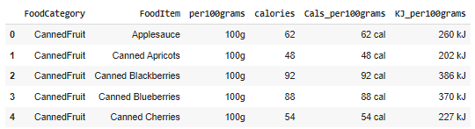

**Figure 1: First Five record of Dataset**

**Data Columns**



**Figure 2: Columns of Dataset**

**NAN Value Representation**

It seems like you're loading a dataset named "food.csv" into a Pandas Data Frame and then checking for missing values (NANs) in the dataset. This code looks good! It reads the CSV file and then uses the isna().sum() method to count the number of missing values in each column. Finally, it creates a new Data Frame to display the count of NAN values for each column.

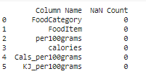

**Figure 3: Nan Value count columns of Dataset**

**Histogram of Calories**

This code will create a histogram of the calorie content per 100 grams of the fruit items in the Data Frame. Adjust the bins parameter to change the number of bins in the histogram for better visualization. You can further customize the plot by modifying parameters such as colour, title, labels, etc., according to your preferences.

.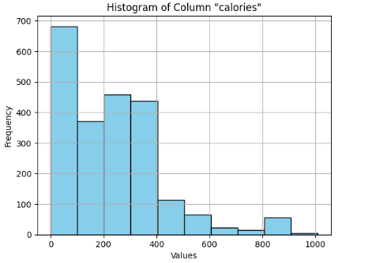

**Figure 4: Histogram of Calories Dataset**

This code will create a bar plot where the x-axis represents the calorie content per 100 grams, and the y-axis represents the frequency of fruit items with that particular calorie content. Adjust the fig size, colours, titles, labels, etc., according to your preferences for better visualization.

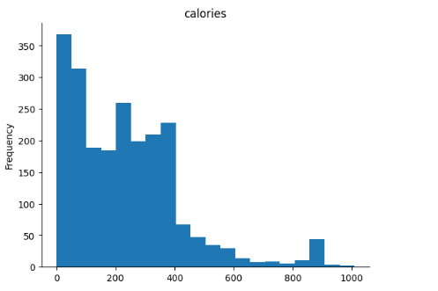

**Figure 5: Frequency vs Calories**

This code will create a bar plot where each bar represents the calorie content per 100 grams of a specific item. Adjust the fig size, colours, labels, etc., according to your preferences for better visualization.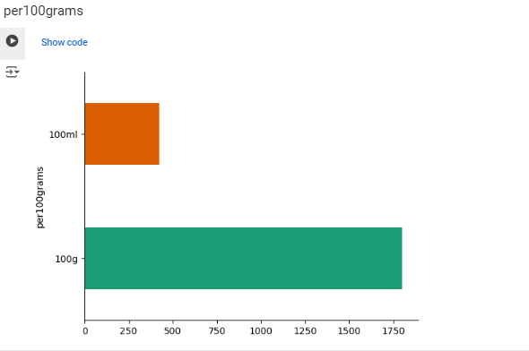

**Figure 6: Grams wise calories**

This code will create a scatter plot where each point represents a fruit item, with its x-coordinate being the weight per serving (in grams) and its y-coordinate being the calorie content per 100 grams. Adjust the fig size, colours, labels, etc., according to your preferences for better visualization.

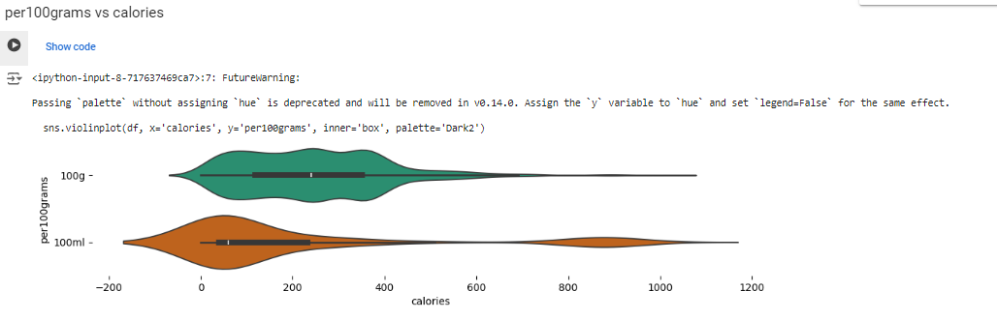

**Figure 7: Grams vs calories**

This code will create a pair plot for the selected columns (FoodCategory, FoodItem, per100grams, calories, Cals_per100grams). Adjust the columns as needed. The pair plot will show scatterplots for all possible pairs of these columns and histograms for the diagonal elements.

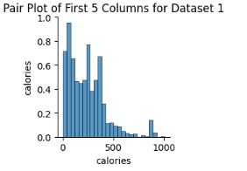

**Figure 8: Pair of First 5 columns**

This code will generate a density plot for the "Calories" column, showing the distribution of calorie content per 100 grams across the fruit items in your Data Frame. Adjust the fig size, colours, labels, etc., according to your preferences for better visualization.

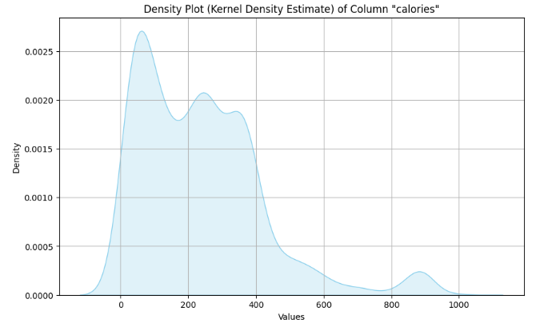

**Figure 9: Density Plot of column “Calories”**

This code will generate a violin plot for the "Calories" column, with the distribution of calorie content per 100 grams visualized using violin plots. Additionally, individual data points will be overlaid on top of the violin plot for each fruit item. Adjust the fig size, colours, labels, etc., according to your preferences for better visualization.

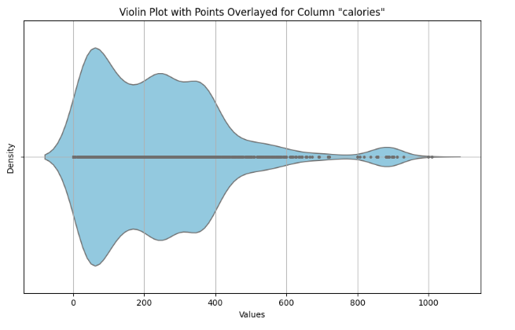

**Figure 10: Violin ­Plot with Points Overplayed for column “Calories”**

These statistics will give you insights into the distribution and central tendency of the calorie content per 100 grams of canned fruits in your dataset. Adjust the code according to your specific Data Frame structure and column names.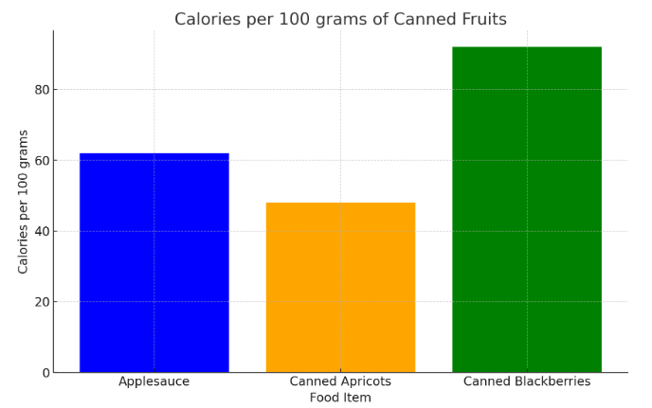

**Figure 11: Calories per 100 grams of canned fruits**

This will provide you with insights into the distribution and central tendency of the kilojoules per 100 grams of canned fruits in your dataset.

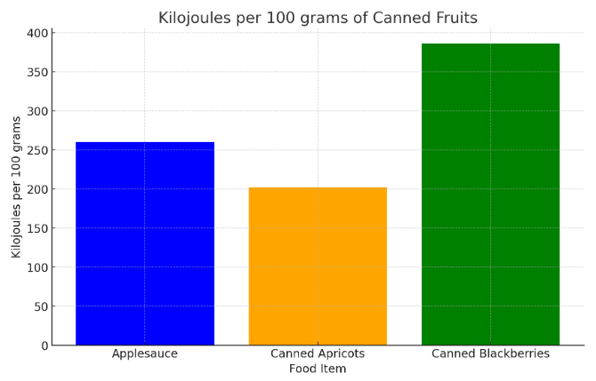

**Figure 12: Kilojoules per 100 grams of canned fruits**

This code will sort the Data Frame by the "calories" column in descending order and then select the top 5 rows, representing the canned fruit items with the highest calorie content per 100 grams.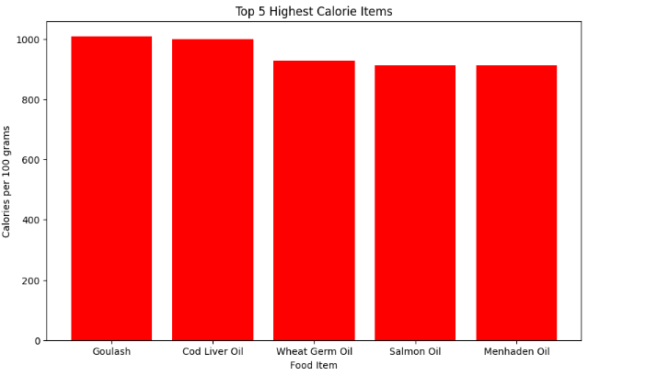**Figure 13: Top 5 Highest calories items**

This code will create a histogram showing the distribution of calorie content per 100 grams among fruit items. Adjust the number of bins, colours, labels, etc., according to your preferences for better visualization.

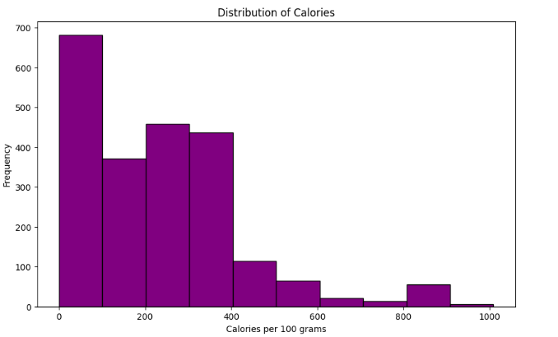

**Figure 14: Distribution of calories**

This code will generate a box plot showing the distribution of calories in your dataset.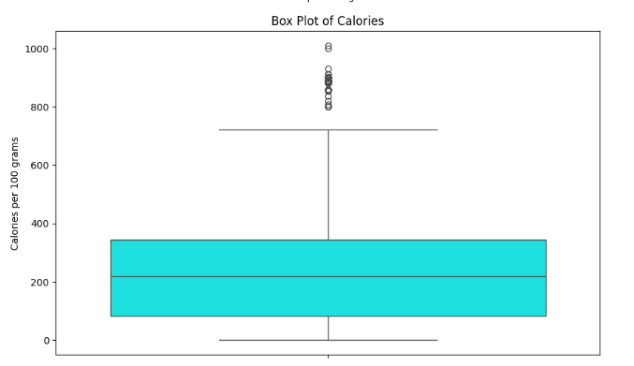

**Figure 15: Box plot of calories**

This code will generate a scatter plot comparing the 'Calories' and 'Kilojoules' columns in your dataset. Each point on the plot represents a data point from your dataset, with the x-coordinate corresponding to the calories and the y-coordinate corresponding to the kilojoules. Adjust the alpha parameter to control the transparency of the points.

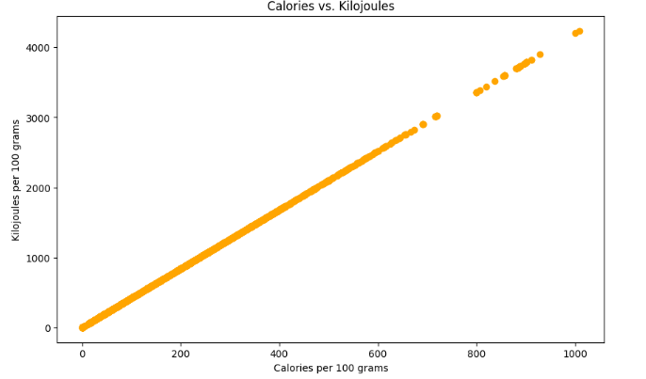

**Figure 16: Calories vs Kilojoules**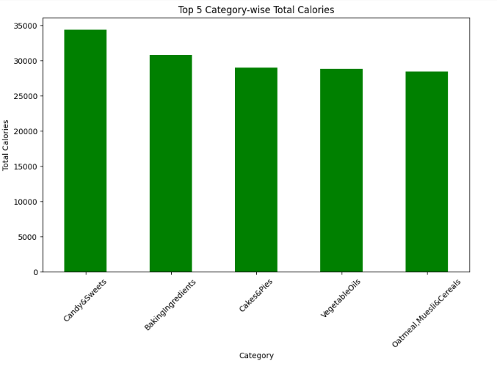

**Figure 17: Top 5 Category-wise total calories**

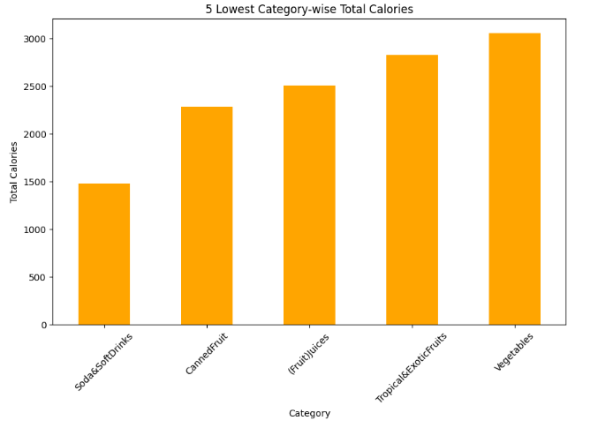

**Figure 18: Top 5 Lowest Category-wise total calories**

This code will output the total number of items in each category in your dataset.

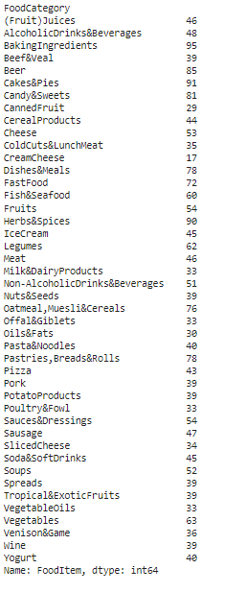

**Figure 19: Displaying the category-wise total items**

# **Chapter 5 – Discussion**

## **5.1 User Registration and Login**

**User Registration:** The application begins with user registration, a crucial step for new users. During registration, users fill out a form providing their name, email, and password. The email must be unique, which is verified using a SQL query to ensure no duplicates exist in the Food_Registration table. The password is hashed using bcrypt before storage, adding a layer of security. Bcrypt is a password-hashing function that incorporates a salt to protect against rainbow table attacks and is computationally expensive, making brute-force attacks difficult. The hashed password, along with the user's name and email, is stored in the database. This hashing process ensures that even if the database is compromised, the original passwords remain secure, as they cannot be easily reverted from their hashed form.

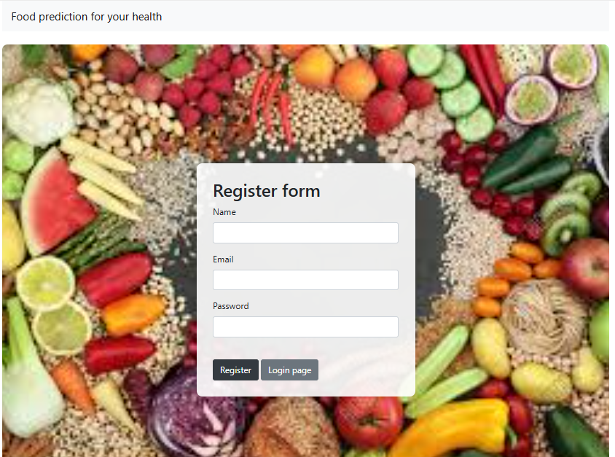

**Figure 20 : Registration page**

**User Login:** Returning users log in by entering their email and password. The login process retrieves the stored hash for the entered email and compares it with the hash of the entered password using bcrypt’s checkpw function. If they match, the user's session is initiated using Flask’s session management, which maintains the user’s login state across different pages. This session-based approach provides a seamless user experience, avoiding the need for re-authentication with each page load. If the login fails, the user is prompted with an error message, guiding them to recheck their credentials.

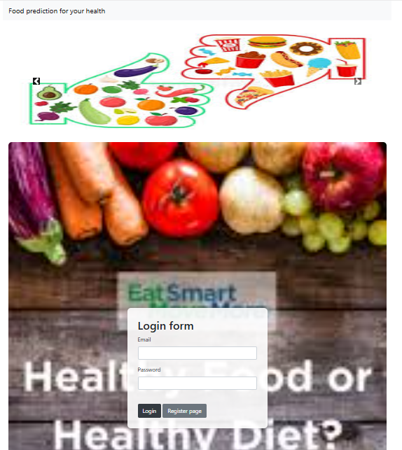

**Figure 21 : Login page**

## **5.2 Form Data Collection**

Once logged in, users access the dashboard, where they are prompted to provide detailed personal information necessary for generating food suggestions. This includes age, weight, height, desired caloric intake, number of food items, gender, user type (e.g., sportsman, diabetic patient), and the preferred meal time (e.g., breakfast, lunch). These inputs are crucial as they directly impact the calculations for caloric needs and food recommendations. The form uses HTML input validation to ensure all required fields are filled correctly before submission, reducing errors and enhancing data integrity. This comprehensive data collection ensures that the suggestions are personalized and tailored to the user’s specific needs and preferences.

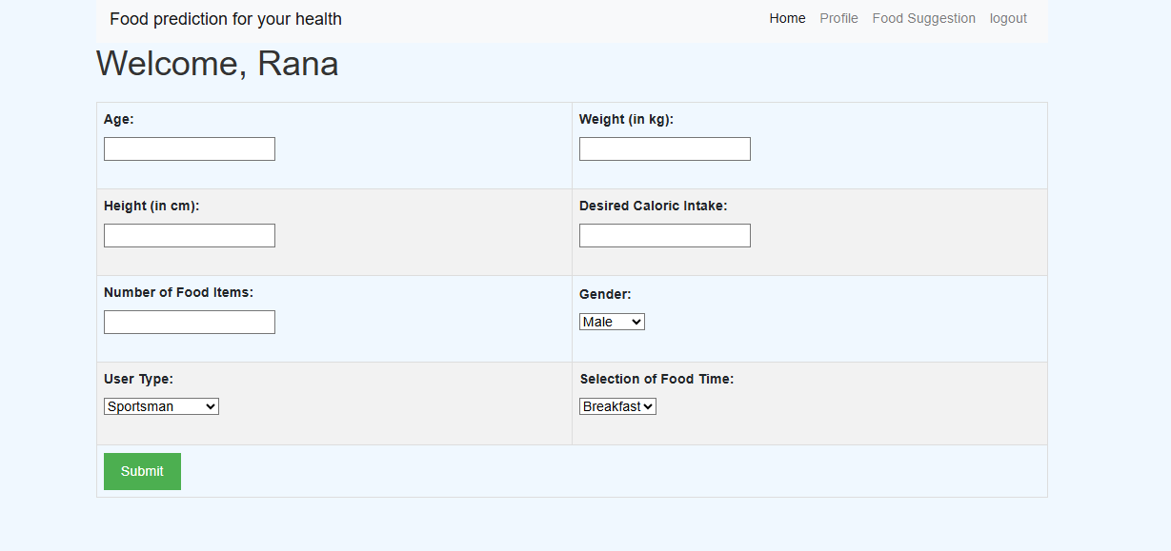

**Figure 22 : Data Collection**

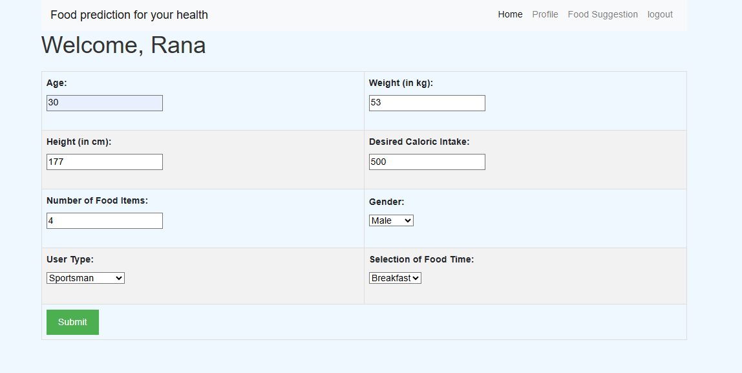

**Figure 23 : Filled Data Collection**

## **5.3 Database Interaction**

The application interacts with a SQL Server database to manage user information and retrieve food data. It uses pyodbc, a Python library that provides an interface for connecting to ODBC databases. When the user submits their details, the application connects to the database to fetch relevant food data. It executes SQL queries to retrieve food items along with their caloric and energy content from the FoodData table. This data retrieval is efficient, ensuring quick access to large datasets. Proper database indexing and query optimization are critical to maintaining performance, especially as the number of users and food items grows. The secure handling of database credentials and connections further ensures data integrity and security.

## **5.4 Food Suggestion Algorithm**

The core functionality of the application is its food suggestion algorithm, which calculates the user’s Total Daily Energy Expenditure (TDEE) and recommends suitable food items. TDEE is calculated using the Basal Metabolic Rate (BMR), which differs by gender and is based on the user's age, weight, and height. For males, the BMR formula is 88.362 + (13.397 * weight) + (4.799 * height) - (5.677 * age), and for females, it is 447.593 + (9.247 * weight) + (3.098 * height) - (4.330 * age). The BMR is then multiplied by an activity factor (1.55 in this case) to estimate TDEE. The algorithm then filters the food data based on the user's type and preferred meal time, sorts it by caloric content, and selects items that collectively meet the desired caloric intake. This selection process considers the number of items the user wants, ensuring variety and balanced nutrition.

## **5.5 Dynamic Rendering**

After processing the input data and generating food suggestions, the results are dynamically rendered on the user’s dashboard. The page displays the user’s estimated TDEE, the suggested food items with their caloric values, and the total calories of the selected items. This dynamic rendering is achieved using Flask’s rendering capabilities, which incorporate Jinja2 templates. The interface is designed to be user-friendly and informative, with clear labelling and organization of data. This visualization helps users easily understand how each food item contributes to their overall caloric intake, aligning with their dietary goals. By providing a detailed and personalized food plan, the application aids users in making informed dietary choices, promoting healthier eating habits. The design and user experience considerations ensure that users can navigate the application smoothly and benefit from its features effectively.

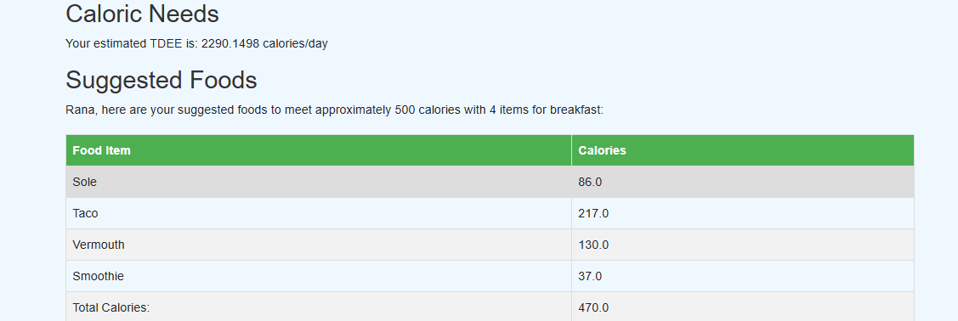

**Figure 24 : Outcome of food suggestion**

# **Chapter 6 - Recommendations & Conclusion**

## **6.1 Recommendations**

The Food Suggestions application is a sophisticated system designed to provide personalized dietary recommendations based on user-specific data. While the current implementation is functional and offers a good foundation, there are several areas where enhancements can be made to improve usability, security, scalability, and overall user experience. Here are detailed recommendations to optimize and extend the application's capabilities. Enhanced User Registration and Authentication the current user registration and login process is robust, utilizing bcrypt for password hashing and ensuring unique email validation. However, incorporating additional layers of security such as multi-factor authentication (MFA) could significantly bolster user account security. MFA would require users to provide two or more verification methods, reducing the risk of unauthorized access. Additionally, implementing email verification during registration can prevent the creation of fake accounts and ensure that users provide valid contact information. This can be achieved by sending a confirmation email with a verification link that the user must click to activate their account. Enhancing user profile management capabilities would allow users to update their personal information, dietary preferences, and goals over time. This feature would make the application more dynamic and user-centric. Users should be able to change their weight, height, and activity levels as they progress in their fitness journey. Including a history of dietary recommendations and caloric intake could help users track their progress and make more informed decisions. This historical data could also be used to provide insights and trends, helping users understand their eating patterns and adjust their habits accordingly.

While the application collects essential data for generating food suggestions, expanding the range of data collected can further personalize recommendations. For instance, collecting information on dietary restrictions (e.g., allergies, vegan/vegetarian preferences), activity level, and specific health goals (e.g., weight loss, muscle gain) can refine the accuracy of the recommendations. This additional information can be integrated into the algorithm to ensure that the suggested foods align not only with caloric needs but also with the user’s dietary constraints and goals. The current implementation uses pyodbc to interact with a SQL Server database. To improve performance, especially with a growing user base, consider optimizing database queries and indexing frequently accessed tables. Implementing database normalization techniques can reduce redundancy and ensure data integrity. Additionally, integrating a database management system (DBMS) that supports horizontal scaling, such as a distributed SQL database, can enhance scalability. Regular database maintenance, such as indexing, updating statistics, and archiving old data, can ensure the database performs optimally. The current food suggestion algorithm is effective but could be enhanced with more sophisticated techniques. Incorporating machine learning algorithms to analyse user data and predict dietary preferences can improve the accuracy of recommendations. For example, collaborative filtering could be used to suggest foods based on the preferences of similar users. Additionally, considering macronutrient distribution (proteins, fats, and carbohydrates) along with caloric intake can provide more balanced meal suggestions. The algorithm can also be refined to suggest portion sizes rather than fixed food quantities, making the recommendations more flexible and realistic.

The application already considers user type (e.g., sportsman, diabetic patient) and meal time (e.g., breakfast, lunch). To enhance this feature, the database schema should include fields that categorize foods by their suitability for different user types and meal times. For instance, certain foods may be more suitable for a sportsman’s diet post-workout, while others may be better for a diabetic patient’s breakfast. The algorithm should dynamically filter and prioritize foods based on these categories, ensuring that the recommendations are not only calorically appropriate but also contextually relevant. Improving the user interface (UI) and user experience (UX) can make the application more engaging and easier to navigate. This includes implementing responsive design to ensure the application works well on various devices, including mobile phones and tablets. Interactive elements, such as sliders for adjusting caloric intake and graphical representations of daily nutritional goals, can make the user experience more intuitive. Additionally, providing tooltips and help icons can assist users in understanding the form fields and the significance of the data being requested. Integrating the application with popular health and fitness apps like Fitbit, My Fitness Pal, or Apple Health can provide a seamless experience for users who track their health metrics. This integration would allow for automatic updates of activity levels, weight, and other health data, ensuring that the food suggestions are always based on the most current information. API integration can facilitate this data exchange, enhancing the overall user experience and providing a holistic view of the user’s health and dietary habits.

Ensuring data privacy and security is paramount, especially when handling sensitive health information. Implementing robust encryption methods for data at rest and in transit can protect user data from breaches. Compliance with data protection regulations such as GDPR (General Data Protection Regulation) and HIPAA (Health Insurance Portability and Accountability Act) is essential for maintaining user trust and avoiding legal issues. Regular security audits and vulnerability assessments can help identify and mitigate potential risks. To handle a growing user base and large datasets, the application should be designed for scalability. Using cloud-based solutions for hosting the database and application can provide the necessary resources to scale up or down based on demand. Implementing caching strategies, such as using Radis or Me cached, can reduce the load on the database by storing frequently accessed data in memory. Load balancing can distribute incoming requests across multiple servers, ensuring high availability and reliability. Implementing a system for personalized notifications and reminders can enhance user engagement and adherence to dietary plans. Users can receive reminders for meal times, notifications about their progress towards nutritional goals, and alerts for updating their weight or activity levels. Push notifications, email alerts, or in-app messages can be used to deliver these reminders. Additionally, personalized tips and motivational messages can encourage users to stay committed to their health goals.

## **6.2 Conclusion**

The Food Suggestions application stands as a promising tool in the landscape of health and wellness technology, designed to provide personalized dietary guidance to users based on their individual health parameters and lifestyle choices. This application integrates several innovative features, from personalized food recommendations and user-specific nutritional insights to community engagement and professional support. Through a user-friendly interface and robust backend, it strives to offer an effective and engaging experience for users aiming to improve their dietary habits and overall health. Central to its functionality is the collection and processing of user data, such as age, weight, height, gender, activity level, and specific dietary goals. This data is leveraged to calculate the Total Daily Energy Expenditure (TDEE) and suggest appropriate foods that align with the user's caloric needs and health objectives. Incorporating a diverse database of food items, the application ensures that users receive varied and nutritionally balanced suggestions, accommodating different dietary preferences and restrictions. To enhance user engagement and satisfaction, the application can benefit significantly from integrating additional features. Personalized notifications and reminders can keep users on track with their meal plans and health goals, while community features like forums and social media integration can foster a supportive environment. Detailed nutritional information for each suggested food item can educate users and help them make informed dietary choices. Customizable meal plans can cater to specific dietary preferences, further personalizing the user experience. Moreover, professional guidance from dietitians, nutritionists, and fitness experts can add value, providing users with credible advice and personalized support. Regular updates, user feedback mechanisms, and gamification elements can ensure the application remains engaging, relevant, and user-friendly. Offline access and multilingual support can expand its reach and usability, making it accessible to a broader audience.

However, the success of the Food Suggestions application hinges on its ability to continuously evolve and adapt to user needs. Regularly updating the application with new features, bug fixes, and performance improvements is crucial. Implementing a robust feedback mechanism where users can suggest features, report issues, and provide comments can help the development team understand user needs and prioritize enhancements. Beta testing new features with a select group of users can ensure that updates meet user expectations and function correctly before a full release. Data analytics can provide valuable insights into user behaviour, dietary patterns, and health outcomes, enabling users to make data-driven decisions about their diet and lifestyle. This can enhance the application's effectiveness and user satisfaction. Gamification elements such as badges, achievements, and leader boards can make the application more engaging, motivating users to stay active on the platform and achieve their health objectives. In conclusion, the Food Suggestions application has the potential to become a cornerstone in personalized dietary guidance. By implementing the recommended features and continuously evolving based on user feedback and technological advancements, it can significantly enhance user experience, security, and scalability. These improvements will ensure the application remains competitive in the health and wellness market, attracts a larger user base, and effectively supports users in achieving their health goals. Through continuous innovation and a user-centric approach, the Food Suggestions application can become an essential companion for anyone looking to improve their diet and overall well-being. As it grows and adapts, it can help users make informed dietary choices, stay motivated, and achieve a healthier lifestyle, ultimately contributing to a broader impact on public health.

**References**

1. Holzapfel, C., Dawczynski, C., Henze, A. and Simon, M.C., 2021. Personalized dietary recommendations for weight loss. A scientific perspective from various angles. *Ernahr. Umsch*, *68*, pp.26-35.
2. Aruoma, O.I., Hausman-Cohen, S., Pizano, J., Schmidt, M.A., Minich, D.M., Joffe, Y., Brandhorst, S., Evans, S.J. and Brady, D.M., 2019. Personalized nutrition: translating the science of nutrigenomics into practice: proceedings from the 2018 American College of Nutrition Meeting. *Journal of the American College of Nutrition*, *38*(4), pp.287-301.
3. Drabsch, T. and Holzapfel, C., 2019. A scientific perspective of personalised gene-based dietary recommendations for weight management. *Nutrients*, *11*(3), p.617.
4. Zeisel, S.H., 2020. Precision (personalized) nutrition: understanding metabolic heterogeneity. *Annual review of food science and technology*, *11*, pp.71-92.
5. Ngiam, K.Y. and Khor, W., 2019. Big data and machine learning algorithms for health-care delivery. *The Lancet Oncology*, *20*(5), pp.e262-e273.
6. Nurmi, J. and Lohan, E.S., 2021. Systematic review on machine-learning algorithms used in wearable-based eHealth data analysis. *IEEE Access*, *9*, pp.112221-112235.
7. Tohka, J. and Van Gils, M., 2021. Evaluation of machine learning algorithms for health and wellness applications: A tutorial. *Computers in Biology and Medicine*, *132*, p.104324.
8. Chiu, Y.L., Jhou, M.J., Lee, T.S., Lu, C.J. and Chen, M.S., 2021. Health data-driven machine learning algorithms applied to risk indicators assessment for chronic kidney disease. *Risk Management and Healthcare Policy*, pp.4401-4412.
9. Koumpouros, Y., 2022. User-Centric Design Methodology for mHealth Apps. The PainApp Paradigm for Chronic Pain. Technologies 2022, 10, 25.
10. TANIS, J. and DAUKSAITE, E., 2022. THE BENEFITS OF PATIENT PERSPECTIVES IN HEALTH TECHNOLOGY DEVELOPMENT.
11. Banton, M., Bowles, J., Silvina, A. and Webber, T., 2021, June. On the benefits and security risks of a user-centric data sharing platform for healthcare provision. In *Adjunct Proceedings of the 29th ACM Conference on User Modeling, Adaptation and Personalization* (pp. 351-356).
12. Zahid, A. and Sharma, R., 2023. Personalized Health Care in a Data-Driven Era: A Post–COVID-19 Retrospective. *Mayo Clinic Proceedings: Digital Health*, *1*(2), p.162.
13. Abd-Alrazaq, A., Safi, Z., Alajlani, M., Warren, J., Househ, M. and Denecke, K., 2020. Technical metrics used to evaluate health care chatbots: scoping review. *Journal of medical Internet research*, *22*(6), p.e18301.
14. Asan, O. and Choudhury, A., 2021. Research trends in artificial intelligence applications in human factors health care: mapping review. *JMIR human factors*, *8*(2), p.e28236.
15. Denecke, K., Gabarron, E., Grainger, R., Konstantinidis, S.T., Lau, A., Rivera-Romero, O., Miron-Shatz, T. and Merolli, M., 2019. Artificial intelligence for participatory health: applications, impact, and future implications. *Yearbook of medical informatics*, *28*(01), pp.165-173.
16. Amiri, Z., Heidari, A., Darbandi, M., Yazdani, Y., Jafari Navimipour, N., Esmaeilpour, M., Sheykhi, F. and Unal, M., 2023. The personal health applications of machine learning techniques in the internet of behaviors. *Sustainability*, *15*(16), p.12406.
17. Kasula, B.Y., 2021. Ethical and Regulatory Considerations in AI-Driven Healthcare Solutions. *International Meridian Journal*, *3*(3), pp.1-8.
18. Nasir, S., Khan, R.A. and Bai, S., 2024. Ethical Framework for Harnessing the Power of AI in Healthcare and Beyond. *IEEE Access*, *12*, pp.31014-31035.
19. Elendu, C., Amaechi, D.C., Elendu, T.C., Jingwa, K.A., Okoye, O.K., Okah, M.J., Ladele, J.A., Farah, A.H. and Alimi, H.A., 2023. Ethical implications of AI and robotics in healthcare: A review. *Medicine*, *102*(50), p.e36671.
20. Iqbal, J., Jaimes, D.C.C., Makineni, P., Subramani, S., Hemaida, S., Thugu, T.R., Butt, A.N., Sikto, J.T., Kaur, P., Lak, M.A. and Augustine, M., 2023. Reimagining healthcare: unleashing the power of artificial intelligence in medicine. *Cureus*, *15*(9).